BOROUGH OF STOCKTON !IMPORTANT!
PO Box M
Stockton, New Jersey 08559
Phone: 609-397-0070
Dear Stockton Water Department Customer:

The Stockton Water Department will be conducting legally required inspections of water meters and service line connectors in basements/utility areas in the coming months.
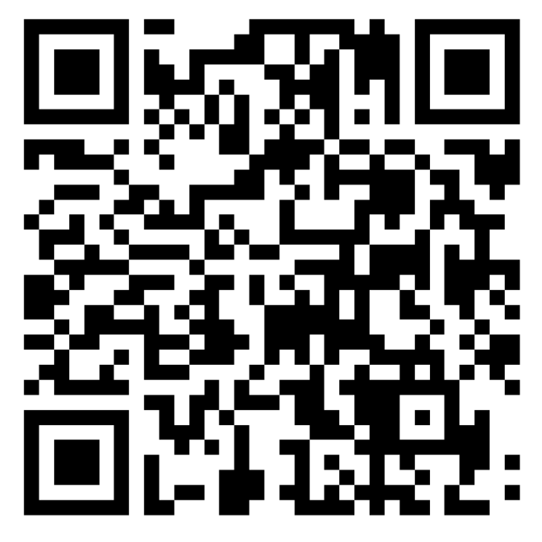
To facilitate these inspections, and to assist with future municipal communications, please provide your contact information by using ONE of the following methods.
- Use this link to fill out the form: https://forms.cloud.microsoft/r/0PQpwhSiFA (also found on the Borough website), or
- Scan this QR code with your phone or tablet to fill out the form
- Email your contact information to stocktonmeterinspection@gmail.com, or
- Fill in the information on the BACK OF THIS PAGE and drop it off at Borough Hall or mail it to:
Stockton Meter Inspections
PO Box M
Stockton, NJ 08559
Information about the Inspections & Meter Replacement:
Some inspections will be brief; however, meters that need replacement or repairs could take one (1) hour or more. Please note that water service will be temporarily shut off during these repairs.
Inspections and repairs/replacements will be conducted by Borough Water Department staff carrying Borough employee IDs.
The inspections will begin on South Main Street, Bridge Street, and Church Street. After that, they will extend to other parts of the Borough, so you may not be contacted for several months about scheduling an inspection on your property.
The inspections will take place primarily on weekends and in the evenings. An adult must be present during the inspection.
If you have any questions, please leave a message at 609-397-0070 or email Mayor Lipsen at alipsen@stocktonboronj.us
Thank you in advance for your assistance as we continue to improve our water system.

The Stockton Borough Water Department

Stockton Borough Water Department
Contact Information for Water Meter Inspections

Your Name(s): _________________________________________________________________________________

Your Home Address: ___________________________________________________________________________

Best Phone Number to Contact You: _____________________________________________________________
Can we send text messages to this number? Yes No

Alternate Phone Number: _______________________________________________________________________
Can we send text messages to this number? Yes No

Email Address: _________________________________________________________________________________

Availability for granting access for meter inspections (please check all that apply):
- Weekdays after 4:00 PM
- Weekends
- Other _________________________________________________________________________________

